Let Me Tell You a Story about Chinna Shodhyatra
Posted byAnusha VelamuriJuly 30, 2026Posted inUncategorizedTags:Chinna shodh Yatra, Education, Experience, learning, Palle srujana, Rural life, Villages
Before getting into the deeds I did this weekend, here is a small prelude that you need to know to understand things better
Palle Srujana is a volunteer organisation that works with grassroots innovators in Andhra Pradesh and Telangana. They scout for knowledge, document it, help validate it and, if found market potential assist in its dissemination too.
One of their activities is the ‘Chinna Shodhayatra’, where participants are encouraged to learn from villages by walking across them for three days.
So, this time, it was the 57th Chinna Shodhayatra, from Machnoor to Singitham village in the Zaheerabad region, covering approximately 30 to 40 kms from 24 to 26 July 2026. And the story goes like this…
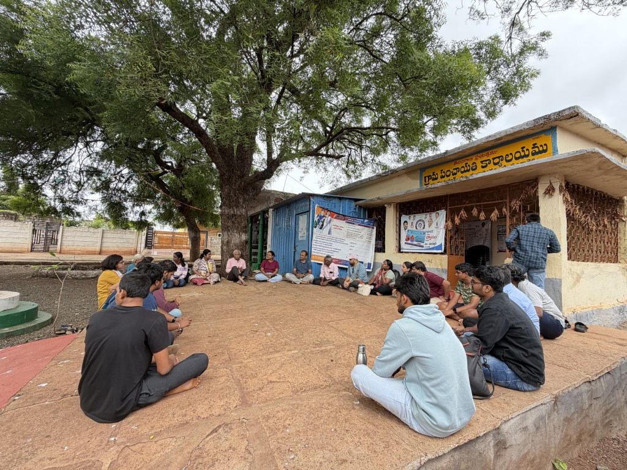

People From Different Walks of Life
Surrounded by engineers all the time, when I see and hang out with a group of 30–35 people that included a ninth-class student, an intermediate student pursuing open-school education, startup founders, an All-India Radio employee, a natural farming practitioner, and a science curriculum designer for students, it becomes a much-needed needle to burst my shallow bubble and widen my horizons. Coming from an agriculture background, it makes me believe that I can have a place in this world too.

A Teacher Who Inspired Action
Five students from Kurnool tagged along with their teacher to participate in this Yatra. They had their apprehensions and doubts, but they still took action, which clearly showed the influence their teacher had on them. They knew that if anything happened, their teacher would listen to them, understand, respect their opinions, and take care of them.
In my profession, where I may have to encourage people to take action, seeing a teacher who inspired and instigated action made me make a mental note. It gave me the hope of someday inspiring others—not just teaching them.
A Phrase of the Yatra That Gave Me Something to Think About: The Brigadier said:
“Previously, there were individual talents and creative people who were appreciated by kings. Example a Birbal, Tenali Ramakrishna. Etc.
When the British came, they thought a group would be better than an individual and institutionalised everything. Now, we have come to a point where creative individuals cannot enter the system, and the systems themselves are lacking creativity.”
Wow, that’s a crazy observation, and I can’t agree with it more.

Now Let’s Get Into the Village and Understand the People

A Community Radio Station as a Pillar of Heritage
We entered the Deccan Development Society’s Sangham Radio station, where content is generated by the people, for the people of that community. They showcased their heritage through a small folk song. The gist of the song was that there was once a riot in a village over land between two castes. Isn’t it a beautiful way of freezing time through art?
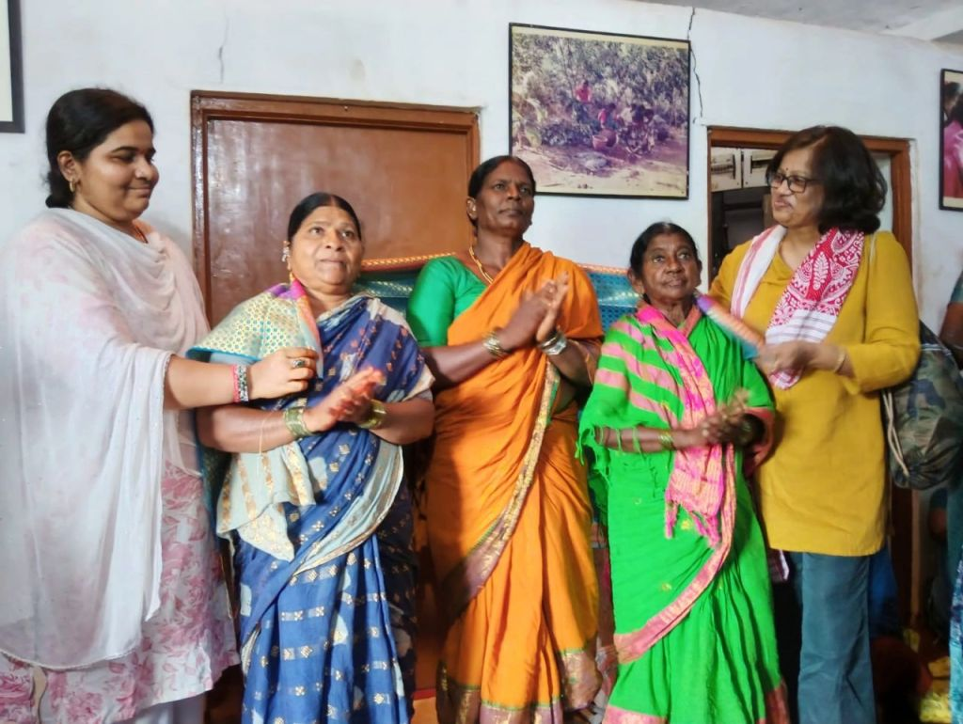
They then told us about a schooling system that emerged because many children of farm labourers were simply hanging around the fields. They started a system with five classes, each named after a bird. The classes were not based on age but on the skill level of the student.
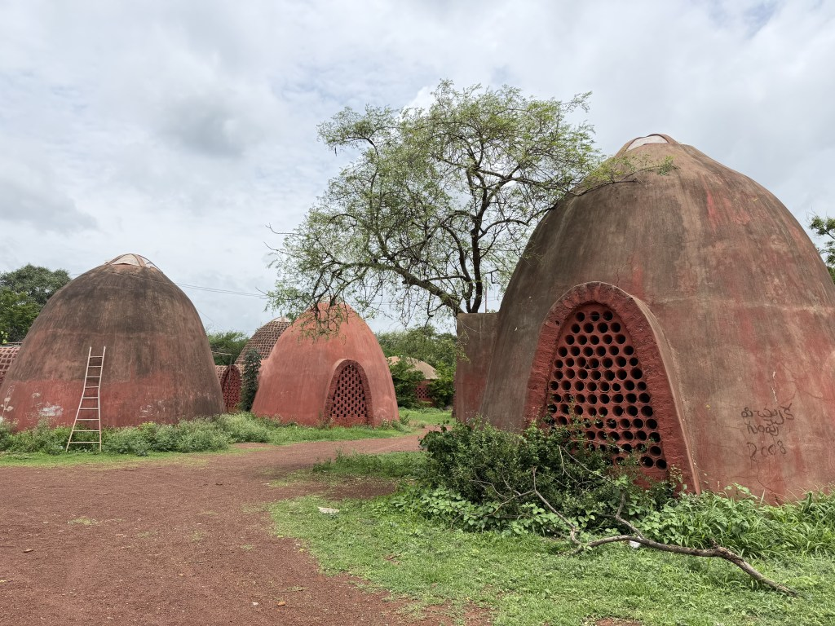

In the mornings, there used to be short classes on language and health, etc. Later, the students would be taught skills that were useful and needed by the villagers. These skills changed every two weeks. At the end, a joint practical examination was conducted. Students were asked what they found most interesting, while the teachers assessed their skill levels- whether they were good at what they did—and later guided them in relevant directions.
Wow!!
A school not designed by Harvard or Oxford—a school for the villagers, by the villagers, and connected to the village. A true example of self-reliance.
(Here, I am hyperlinking their YouTube channel: Sangham Radio. Do subscribe and learn more about them.)

Rural Women and Their Wages
When I asked a woman how much they earn if they go to the fields to carry out farm operations, she said Rs.300 per day for working from 10 a.m. to 5 p.m. Damn!!
Agriculture is such a seasonal occupation and demands huge amounts of labour. There may be only 50 to 70 working days in a season, and even that varies depending on climate and resource availability. And this woman spoke to us the entire time with a wide smile, wondering how we had come from the city and were walking across villages.
There is something huge that I am missing. I still do not understand how rural households manage to sustain themselves under such uncertain conditions.

His Experiments with Farming
Then, I met a cotton farmer who was growing a vegetable crop on a few cents of land while the entire surrounding area was covered with cotton across large acres.
He casually said:
“Yeah! I wanted to try and see how it goes. Last time, I grew tomatoes, but they didn’t yield well, and I ended up with a loss of Rs.1 lakh. This time, I am trying this.”
Advertisement
I was like, “Dude, did I hear that right?!”
I am in my twenties, where I can take risks, make mistakes, and learn when I stumble. Even when I get caught up in hurdles that can easily be counted as experience, I go into a nutshell and have a guilt trip before coming out of it.
Here, you are losing real, physical money, yet you wake up and decide to conduct another experiment.
Dear Indian farmer—what are you guys made of?

Kids Interested in the Army
When one of our group members found that some children who love India and wanted to join the Army, she brought them to the Brigadier who was leading the Shodha yatra. He actively encouraged them to ask questions.
They asked:
“Have you killed people?”
Then:
“Have you used an AK-47?”
And later:
“How much will we be paid?”
This made me reflect on the kind of things we, as a society, are moving towards.
A seventh-class child spoke about violence and money while discussing a noble profession that is much more than that. See, I am not questioning or blaming the child. My concern is with society, the things we are glorifying and the materialism we are promoting.
Well, it’s a topic of its own; let’s take that in another blog and continue with this one

And Finally, the Innovator
An innovator named Mr Praveen, who developed a mulberry shoot harvester, shared his journey. Along with the innovation, he spoke in detail about his journey, where he faced some atrocious conditions and ill-treatment when he worked abroad. But now, when he is employing 12 people, the principles he follows to safeguard their health clearly show that human values cannot be taught in an MBA.
I am an ardent believer in this:
“If someone did something to you that hurt you, you should not do it to others. Breaking the cycle is what leads to a new way of order.”
Seeing a man act on this principle really made me feel nice and affirmed my belief.

Another Take-home message for me
One of the Yatris said:
“For an engineer, when they see these grassroots innovations, they might not appear to be engineering marvels. It could simply be a motor, piston, pulley and other components arranged together. But sadly, no engineer is seeing the problem or coming forward to solve rural problems. That is why a grassroots innovator had to emerge.”
That’s the best summary of all the stories

And There Was More…
Now that you have read all this, don’t think you got it all.
There was a conversation with an old woman, eating tamarind chocolate, encountering a police check, a dog that followed us across villages, and the list goes on…
Some experiences cannot be fully captured in words. They have to be walked, heard, and felt.
Thanks for reading this long. Anusha
Read my previous impressions from the 52nd Chinna Shodh yatra here: https://www.pallesrujana.org/2024/FAQs%20of%20Chinna%20Shodhyatra%20Anusha.pdf

